# Overview

This document contains the necessary information to build the Open Playback Recorder.

Contents

Overview 1

Maker Checklist 5

Maker To Do List 5

Items to Give to User 5

Tool List 6

Customization Guide 7

3D Printing Guide 8

3D Printing Summary 8

3D Printing Settings 8

Post-Processing 8

Examples of Quality Prints 9

Assembly Guide 13

Required Components 13

Required Tools 14

Required Personal Protective Equipment (PPE) 14

Step 1: Place the microcontroller 14

Step 2: Attach the microSD reader 15

Step 3: Attach Connecting Header 15

Step 4: Attach Speaker Amp 16

Step 5: Attach Battery Connector 16

Step 6: Power to microcontroller 17

Step 7: Connect the Amp to Ground 17

Step 8: Connect Amp to power 18

Step 9: Short the differential 18

Step 10: Amp signal in 19

Step 11: Microcontroller signal out 19

Step 12: Amp shut down pin 20

Step 13: Connect microSD power 20

Step 14: Connect microSD to ground 21

Step 15: Connect the amp output 21

Step 16: Finish connecting amp wires 22

Step 17: Connect microSD clock line 22

Step 18: Connect DO line 23

Step 19: Connect DI line 23

Step 20: Connect CS line 24

Step 21: Strip button wires 24

Step 22: Connect button wires to microcontroller 25

Step 23: Connect microphone input 25

Step 24: Connect the record LED 26

Step 25: Connect the play LED 26

Step 26: Connect the level LEDs 27

Step 27: Connect microcontroller power 27

Step 28: Connect microcontroller ground 28

Step 29: Prep the buttons 28

Step 30: Insert the buttons 29

Step 31: Cover the buttons 29

Step 32: Prepare the jacks 30

Step 33: Insert the jacks 30

Step 34: Place the button covers 31

Step 35: Connect a common ground 31

Step 36: Connect the level inputs 32

Step 37: Connect the play buttons 33

Step 38: Connect a ground wire 34

Step 39: Attach the protoboard 34

Step 40: Connect the common ground to the protoboard 35

Step 41: Connect the buttons 36

Step 42: Add the battery cover 37

Step 43: Insert the microSD card reader 37

Step 44: Add the power switch 38

Step 45: Add the potentiometer 38

Step 46: Add the volume knob 39

Step 47: Add the microphone 39

Step 48: Place the button covers 40

Step 49: Connect the grounds 40

Step 50: Attach the speaker 41

Step 51: Attach the header to the protoboard 41

Step 52: Insert the resistors 42

Step 53: Prep the power wires 42

Step 54: Attach the power wires 43

Step 55: Attach more wires 44

Step 56: Attach resistor wires 45

Step 57: Attach the final wires 45

Step 58: Attach the speaker 46

Step 59: Attach the protoboard 46

Step 60: Connect the power wires 47

Step 61: Connect the ground 48

Step 62: Connect the microphone 49

Step 63: Connect the potentiometer 49

Step 64: Place the button covers 50

Step 65: Finish the common ground 50

Step 67: Connect the level LEDs 51

Step 68: Attach the connector to the top half 51

Step 69: Attach connector to the bottom half 52

Step 70: Insert the battery 52

Step 71: Program the microcontroller 53

Programming 53

Step 1: Setup Arduino IDE on Computer 53

Step 2: Open the Library Manager 53

Step 3: Search the TMRpcm library 54

Step 4: Enable Recording 54

Step 5: Open the Preferences 55

Step 6: Add the Board URL 56

Step 7: Connect the Open Playback Recorder to the Computer 56

Step 8: Program the Microcontroller 57

Step 10: Close the enclosure 57

# Maker Checklist

This list provides an overview of the steps required to build and deliver the device.

## Maker To Do List

* Read through the Assembly Guide to become familiar with required components, tools, supplies, and safety gear and overall assembly steps.
* Talk to User about customization options (e.g., color, any special requests, etc.)
* Order hardware components
* Gather tools, supplies, and safety equipment.
* Assemble the device
* Test device
* Print “User Guide”

## Items to Give to User

* Assembled, tested device
* “User Guide”

# Tool List

* 3D printer
* Soldering iron and solder
* Wire cutters
* Wire strippers
* Small flathead screwdriver
* Small Phillips screwdriver
* Hot glue gun (optional)

# Customization Guide

The device can be printed in the user’s desired colour.

# 3D Printing Guide

## 3D Printing Summary

|  |  |
| --- | --- |
| **Metrics** | **Single Unit** |
| Total Print Time (min) | 1397 (23h17) |
| Total Number of Components | 10 |
| Typical Total Mass (g) | 109 |
| Typical Number of Print Setups | 1 |

## 3D Printing Settings

|  |  |  |  |  |  |  |  |
| --- | --- | --- | --- | --- | --- | --- | --- |
| **Print File Name** | **Qty** | **Total Print Time (hr:min)** | **Mass (g)** | **Infill (%)** | **Support(Y/N)** | **Layer Height/ Nozzle Diameter(mm)** | **Notes** |
| Base.stl | 1 | 9:37 | 45 | 20 | N | 0.2/0.4 |  |
| Battey Cover.stl | 1 | 1:24 | 7 | 20 | N | 0.2/0.4 |  |
| Button Mount.stl | 3 | 0:08 | 1 | 20 | N | 0.2/0.4 |  |
| Level Button.stl | 1 | 0:08 | 1 | 20 | N | 0.2/0.4 |  |
| Lid.stl | 1 | 11:17 | 51 | 20 | N | 0.2/0.4 |  |
| Play Button.stl | 1 | 0:08 | 1 | 20 | N | 0.2/0.4 |  |
| Record Button.stl | 1 | 0:08 | 1 | 20 | N | 0.2/0.4 |  |
| Volume Knob.stl | 1 | 0:27 | 2 | 20 | N | 0.2/0.4 |  |

## Post-Processing

* Use a hobby knife to remove any burrs or bumps

## Examples of Quality Prints

**Photo of Base.stl**

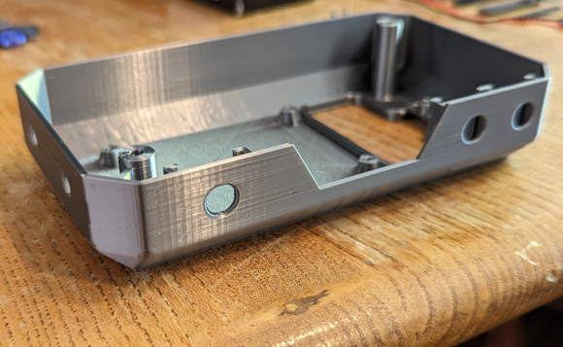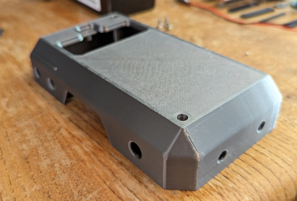

**Photo of Battery Cover.stl**

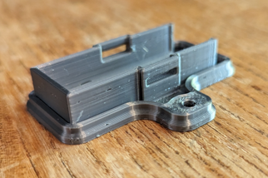 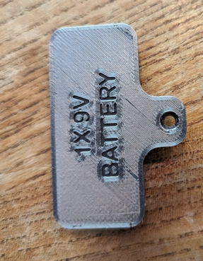

**Photo of Button Mount.stl**

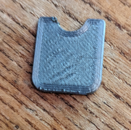

**Photo of Level Button.stl**

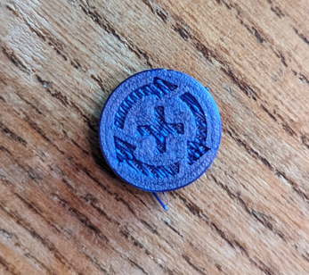

**Photo of Lid.stl**

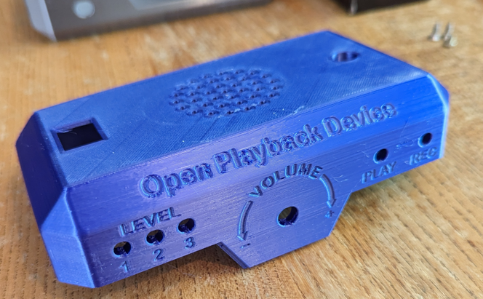 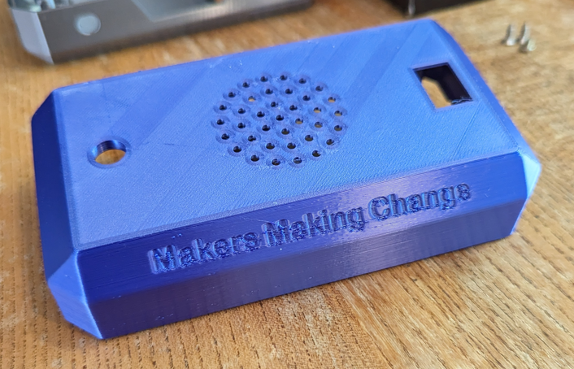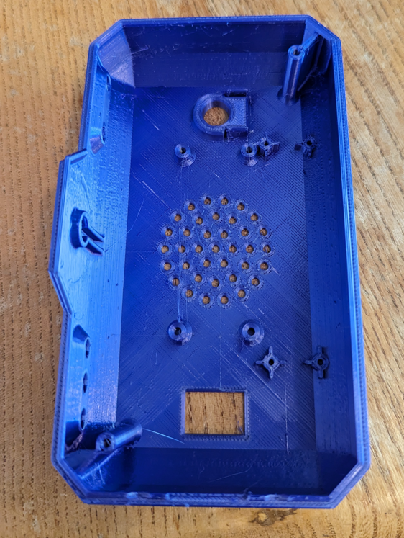

**Photo of Play Button.stl**

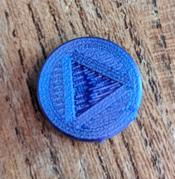

**Photo of Record Button.stl**

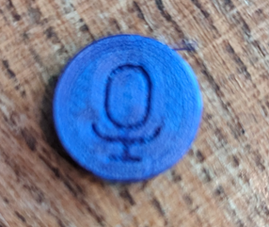

**Photo of Volume Knob.stl**

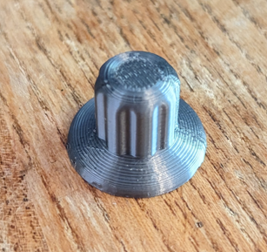

# Assembly Guide

## Required Components

|  |  |
| --- | --- |
|  | **BOM**   1. Base.stl x1 2. 9V Battery x1 3. Battery Cover.stl x1 4. Record Button.stl x1 5. Play Button.stl x1 6. Level Button.stl x1 7. Button Mount.stl x1 8. 18x25 Protoboard x1 9. 3.5mm Jack x2 10. MicroSD Reader x1 11. MicroSD Card x1 12. Press Button x3 13. Speaker Amp x1 14. Microphone x1 15. Seeduino Nano x1 16. 15 Pin Female Header x2 17. 14 Pin Male Header x1 18. 8 Pin Female Header x1 19. M2 Screws x4 20. 9V Battery Connector x1 21. Lid.stl x1 22. Speaker x1 23. Volume Knob.stl x1 24. 14 Pin Male Header x1 25. 28x6 Protoboard x1 26. Power Switch x1 27. Potentiometer x1 28. Blue LED x3 29. Red LED x1 30. Green LED x1 31. 2k Resistor x5 32. M2 Screw x2 33. M3 Screw x4 34. Double Female Dupont Wires x14 35. Solid Core Wire 36. M3 Screw x3 |

## Required Tools

* Soldering Iron
* Solder
* Wire cutters
* Wire strippers
* Flathead screwdriver
* Phillips Screwdriver
* Hot glue (optional)

## Required Personal Protective Equipment (PPE)

* Safety glasses
* Solder fume extractor (optional)

### Step 1: Place the microcontroller

Cut two lengths of female header pins to the length of the pins on the microcontroller (15 pins). Place them on the indicated spots on the protoboard and solder it in place. The microcontroller can be used to keep the spacing correct and keep the pins perpendicular to the protoboard.

|  |
| --- |
| Protoboard with two rows of headers attached Protoboard with two rows of headers and a seeeduino nano attached |

### Step 2: Attach the microSD reader

Cut an eight-pin long length of female header pin. Using the microSD reader as a guide, position the header so that the pins on the microSD reader line up with the GND pin on the microcontroller. Solder the header in place.

|  |
| --- |
| The protoboard assembly with the SD card reader attached, lining up with the ground pin on the microcontroller The back of the protoboard assembly, showing where the headers are soldered |

### Step 3: Attach Connecting Header

Attach a 14-pin male header in the location shown in the protoboard. (Note that the one used in this guide is 15 pins, but a 14 pin is all that is needed)

|  |
| --- |
|  |

### Step 4: Attach Speaker Amp

Take the speaker amp and place it in the same row as the microSD reader, but all the way to the left, and solder it in place.

|  |
| --- |
| The speaker amp, soldered in line with the microSD header, but all the way to the left |

### Step 5: Attach Battery Connector

Connect the ground (black) wire to the leftmost pin on the header and connect the 9V in wire (red) to the third leftmost pin. From this point on in the guide, the pins will be numbered with pin 1 being the leftmost, and pin 14 being the rightmost.

|  |
| --- |
| the protoboard with the battery header attached. Red circles show what pins they are connected to The back of the protoboard, showing the solder joints connecting the wires to the header |

### Step 6: Power to microcontroller

Cut a 2-inch length of wire and use it to connect the fourth pin to the Vin pin on the microcontroller headers (Top right).

|  |
| --- |
| The protoboard assembly, with a wire going from the fourth header pin, to the top left pin on the microcontroller |

### Step 7: Connect the Amp to Ground

Take a half inch piece of wire, and strip both ends. Connect one end to pin 1, and one end to the GND pin on the amp.

|  |
| --- |
| The protoboard assembly with a small wire connecting pin 1 on the header to the ground pin on the speaker amp |

### Step 8: Connect Amp to power

Take another half inch piece of wire, and use it to connect pin 2 to the Vin pin of the amp.

|  |
| --- |
| The protoboard assembly with a small wire connecting pin 2 on the header to the Vin pin on the speaker amplifier |

### Step 9: Short the differential

Using a half inch piece of wire, connect the GND pin to the A- pin on the back of the board.

|  |
| --- |
| The back of the protoboard assembly with a small wire connecting the ground pin to the A- pin on the speaker amplifier |

### Step 10: Amp signal in

Using another half inch piece of wire, connect the A+ pin on the amp to pin 5 on the header.

|  |
| --- |
| The protoboard assembly with a small piece of wire connecting pin 5 on the header to the A+ pin on the speaker amp |

### Step 11: Microcontroller signal out

Cut a three-inch piece of wire and use it to connect pin 6 on the header to pin D9 on the microcontroller.

|  |
| --- |
| The protoboard assembly with a longer wire connecting pin 6 on the header to pin D9 on the microcontroller |

### Step 12: Amp shut down pin

Using a two-and-a-half-inch wire, connect the SD pin on the amp, to pin D8 on the microcontroller.

|  |
| --- |
| The protoboard assembly with a longer wire connecting the SD pin on the speaker amplifier to pin D8 on the microcontroller |

### Step 13: Connect microSD power

Connect the Vin to the 5V pin on the microSD on the back of the board.

|  |
| --- |
| The back of the protoboard assembly with a wire connecting Vin on the speaker to the 5V pin on the microSD card |

### Step 14: Connect microSD to ground

Connect the GND pin of the amp to the GND pin of the microSD reader on the back of the board.

|  |
| --- |
| The back of the protoboard assembly with a wire connecting the ground pin on the speaker amplifier with the ground pin on the microSD card |

### Step 15: Connect the amp output

Connect two 2-inch wires to the output of the amp. It is recommended to trim these wires from the speaker wire, so that they are stuck together, and it will make it easier when making the top half of the device if the colours match.

|  |
| --- |
| The protoboard assembly with two speaker wires connected to the output terminals of the speaker amp |

### Step 16: Finish connecting amp wires

Connect the other side of the amp wire to pins 7 and 8 on the header.

|  |
| --- |
| The protoboard assembly with the speaker wires from the previous picture connected to pins 7 and 8 on the header |

### Step 17: Connect microSD clock line

Using a two-and-a-half-inch wire, connect the CLK pin on the microSD reader to pin D13 on the microcontroller.

|  |
| --- |
| The protoboard assembly with a wire going from the clock pin on the microSD reader to the D13 pin on the microcontroller |

### Step 18: Connect DO line

Using a two-inch wire, connect the DO pin on the microSD to the D12 pin on the microcontroller

|  |
| --- |
| The protoboard assembly with a wire connecting the data out line on the microSD reader to the D12 pin on the microcontroller |

### Step 19: Connect DI line

Using a two-inch wire, connect the DI pin on the microSD to the D11 pin on the microcontroller.

|  |
| --- |
| The protoboard assembly with a wire connecting the data in pin on the microSD reader to the D11 pin on the microcontroller |

### Step 20: Connect CS line

Using a two-inch wire, connect the CS pin on the microSD to the D10 pin on the microcontroller.

|  |
| --- |
| The protoboard assembly with a wire connecting the chip select pin on the microSD reader with the D10 pin on the microcontroller |

### Step 21: Strip button wires

Cut and strip three 4-inch wires.

|  |
| --- |
| Three 4 inch lengths of wire that have had their ends stripped |

### Step 22: Connect button wires to microcontroller

Connect the wires from the previous step to microcontroller pins D3, D4, and D5.

|  |
| --- |
| The three wires from the previous step connected to pins D2, D3, and D4 on the microcontroller |

### Step 23: Connect microphone input

Cut a three-inch piece of wire and use it to connect pin 9 on the header to pin A0 on the microcontroller

|  |
| --- |
| The protoboard assembly with a wire connecting pin 9 on the header to pin A0 on the microcontroller |

### Step 24: Connect the record LED

Use a 2.5-inch piece of wire and connect pin 10 to microcontroller pin A1

|  |
| --- |
| The protoboard assembly with a wire connecting pin 10 on the header to pin A1 on the microcontroller |

### Step 25: Connect the play LED

Use a 2.5-inch piece of wire and connect pin 11 to microcontroller pin A2

|  |
| --- |
| The protoboard assembly with a wire connecting pin 11 on the header to microcontroller pin A2 |

### Step 26: Connect the level LEDs

Use a 2.5-inch piece of wire and connect pins 12, 13, and 14 in order to microcontroller pin A3, A4, A5. In the picture they are raised to show order, but flatten them down to allow the microcontroller to fit in the headers.

|  |
| --- |
| The protoboard assembly with three lengths of wire connecting pins 12, 13, and 14 on the header to microcontroller pins A3, A4, and A5 |

### Step 27: Connect microcontroller power

Using a 1-inch piece of wire, connect the 5V pin on the microcontroller to the 5V pin on the microSD across the back of the board

|  |
| --- |
| The back of the protoboard assembly with a wire connecting the 5V pin on the microcontroller to the 5V pin on the microSD reader |

### Step 28: Connect microcontroller ground

Using a 1-inch piece of wire, connect the GND pin on the microcontroller to the GND pin on the microSD across the back of the board

|  |
| --- |
| The back of the protoboard assembly with a wire connecting the ground of the microcontroller with the ground of the microSD reader |

### Step 29: Prep the buttons

Take the three buttons, cut the plastic buttons as well as two of the four metal pins, and flatten the remaining two.

|  |
| --- |
| Three buttons all at a different angle, with two of the leads and the two plastic bumps trimmed off |

### Step 30: Insert the buttons

Put the buttons in the slots in the base as shown

|  |
| --- |
| One of the buttons inserted in the slot in the base |

### Step 31: Cover the buttons

Slide the button covers in the slots behind the buttons to secure them in place.

|  |
| --- |
| The inserted button covered with the button cover |

### Step 32: Prepare the jacks

Take the rings off of both of the jacks.

|  |
| --- |
| Two 3.5mm jacks with the rings removed |

### Step 33: Insert the jacks

Put the jacks through the holes on the left of the base, and secure them in place with the rings.

|  |
| --- |
| The base with the three buttons and two jacks installed. |

### Step 34: Place the button covers

Place the button covers over the buttons as shown in the below image. If the button covers do not hold themselves on place, some hot glue can be used to secure them.

|  |
| --- |
| The buttons on the base with the proper button covers installed. |

### Step 35: Connect a common ground

Use wire to connect one leg of all the buttons as well as the middle pins of the jacks.

|  |
| --- |
| An inside view of the base with a black wire connecting one leg of every button and jack to form a common ground |

### Step 36: Connect the level inputs

Connect the front pin of the backmost jack to the pin of the level button that is not connected to the common ground.

|  |
| --- |
| The back level jack, with a wire connecting the front tab to the free prong on the level button |

### Step 37: Connect the play buttons

Connect the front pin of the front jack to the pin of the play button that is not connected to the common ground.

|  |
| --- |
| The base assembly, with a wire connecting the front tab of the play jack to the free prong on the play button |

### Step 38: Connect a ground wire

Connect a 2-inch wire to pin 1 on the header

|  |
| --- |
| The protoboard assembly with a wire added to pin 1 on the header |

### Step 39: Attach the protoboard

Using 4 M2 screws, attach the protoboard to the base.

|  |
| --- |
| The protoboard assembly affixed in place in the base |

### Step 40: Connect the common ground to the protoboard

Connect the loose ground wire from step 38 to the common ground of the switches and jacks.

|  |
| --- |
| The wire from step 38 connected to the common ground of all the buttons and jacks |

### Step 41: Connect the buttons

Connect the three wires to the buttons. The one connected to D3 connects to the level button, the one connected to D4 connects to the play button, and the one connected to D5 connects to the record button.

|  |
| --- |
| The three free floating button wires attached to the appropriate buttons |

### Step 42: Add the battery cover

Flip over the base, and insert the battery cover into place and secure with a screw.

|  |
| --- |
| The battery cover inserted in place |

### Step 43: Insert the microSD card reader

Place the microSD card in the reader. The base of the device is now complete

|  |
| --- |
| The fully assembled base |

### Step 44: Add the power switch

Add the power switch to the top of the enclosure. It should press into place and hold itself in. Ensure that the text faces the front of the enclosure.

|  |
| --- |
| The top of the enclosure, with the power button pushed into it's slot |

### Step 45: Add the potentiometer

Take the ring off the potentiometer and put it through the hole in the inside of the enclosure. There will be a slot on the enclosure that fits the tab on the potentiometer. Secure the potentiometer in place with the ring.

|  |
| --- |
| The potentiometer inserted in the slot on the front of the top enclosure |

### Step 46: Add the volume knob

Place the volume knob over the knob on the potentiometer. It should snuggly hold itself in place, but hot glue can be used if needed.

|  |
| --- |
| The volume knob inserted over the control knob on the potentiometer |

### Step 47: Add the microphone

Place the microphone through the hole on the top of the enclosure. The tabs will snap over the PCB and hold it in place.

|  |
| --- |
| The microphone snapped into place in the top of the enclosure |

### Step 48: Place the button covers

Place the LEDs into the slots into the container. The blue LEDs fit into the level holes, the green LEDs fit into the play hole, and the red LED fits into the rec hole. They should be a snug fit, but can be held in place with hot glue if necessary. For later steps, it is helpful to keep all the LEDs with the same direction, with the short legs all facing the top of the enclosure.

|  |
| --- |
| The front of the top enclosure, with the LEDs properly installed A picture showing how the ground leg of the LED is smaller than the power lead |

### Step 49: Connect the grounds

Bend the short wire of the LEDs so they all touch each other and solder them together.

|  |
| --- |
| The LEDs of the top enclosure, with the ground legs bent so they all touch each otherA picture of an LED with the shorter leg highlighted |

### Step 50: Attach the speaker

Using four screws, attach the speaker to the top of the case.

|  |
| --- |
| The speaker connected to the top enclosure |

### Step 51: Attach the header to the protoboard

Cut a length of male header pin to 14 pins long and place it in the top row, two from the right, as shown in the attached image.

|  |
| --- |
| A small protoboard with a 14 pin header attached to it |

### Step 52: Insert the resistors

Take 5 2K resistors and attach them to the five leftmost pins

|  |
| --- |
| The protoboard assembly with five resistors attached to pins 10 though 14 on the header |

### Step 53: Prep the power wires

Cut two 2 inch long lengths of wire and strip the ends

|  |
| --- |
| two 2-inch lengths of red wire with the ends stripped |

### Step 54: Attach the power wires

Solder the power wires to the third and fourth leftmost pins, as seen in the below image

|  |
| --- |
| The protoboard assembly with the wires from the previous step attached to pins 3 and 4 on the header |

### Step 55: Attach more wires

Connect a 3 inch stripped wire to the leftmost pin. Connect a 4 inch female Dupont wire to the second leftmost pin. Attach two 3 inch long wires to the fifth and sixth pins. Finally, connect a 4 inch female Dupont wire to the 9th leftmost pin.

|  |
| --- |
| The protoboard assembly with a three inch wire attached to pin 1, a 4 inch female Dupont wire attached to pin 2, two 3 inch wires attached to pins 5 and 6, and a 4 inch female Dupont wire attached to pin 9 |

### Step 56: Attach resistor wires

Connect a 4 inch female Dupont wire to the leftmost pin, and attach a 3 inch stripped wire to the resistor attached to the 10th pin.

|  |
| --- |
| The protoboard assembly with a 4 inch female Dupont wire attached to pin 1, and a three inch wire attached to the resistor on pin 10 |

### Step 57: Attach the final wires

Strip four lengths of 3 inch long wire, and attach them to all the remaining resistors.

|  |
| --- |
| The protoboard assembly with four more 3 inch wires attached to the remaining resistors |

### Step 58: Attach the speaker

Attach the wires from the speaker to the remaining two pins.

|  |
| --- |
| The protoboard assembly with the speaker wires connected to pins 7 and 8 on the headers |

### Step 59: Attach the protoboard

Using four M2 screws, attach the protoboard to the four posts behind the speaker.

|  |
| --- |
| The protoboard assembly attached to the top enclosure |

### Step 60: Connect the power wires

Connect the wires on pin 3 and 4 to the power switch. Order of the wires is not important.

|  |
| --- |
| The wires attached to pins 3 and 4 connected to the power switch |

### Step 61: Connect the ground

Take the non-Dupont wire on the first pin, and connect it to the bottom tab of the potentiometer, and the ground wire of the three blue LEDs

|  |
| --- |
| The wire attached to pin 1 connected to the ground of the potentiometer and the blue level LEDs |

### Step 62: Connect the microphone

Connect the Dupont wire from the first pin to the GND pin on the microphone. Connect the Dupont wire from the second pin to the V+ pin on the microphone. Finally, connect the Dupont wire on the ninth pin to the Out pin on the microphone.

|  |
| --- |
| The female Dupont wires on pins 1, 2, and 9 connected to pins GND, V+, and Out respectively on the microphone |

### Step 63: Connect the potentiometer

Connect the wire on pin 5 to the middle tab on the potentiometer. Connect the wire on pin 6 to the top tab on the potentiometer. Order is important for this step.

|  |
| --- |
| The wires attached to pins 3 and 4 on the header connected to the remaining two tabs on the potentiometer |

### Step 64: Place the button covers

Connect the wire on pin 10 (the first resistor) to the red LED and connect the wire on pin 11 (the second resistor) to the green LED.

|  |
| --- |
| The green and red LEDs connected to the wires attached to the resistors on pins 10 and 11 |

### Step 65: Finish the common ground

Using a two-inch length of wire, connect the common ground of the green and red LED to the ground of the blue LEDs and the potentiometer

|  |
| --- |
| A length of wire connected to the grounds on the red and green LEDs and the ground  of the potentiometer |

### Step 67: Connect the level LEDs

Connect the wire from the rightmost resistor to the rightmost blue LED. Connect the second rightmost wire to the middle blue LED, and the third rightmost wire to the left blue LED.

|  |
| --- |
| Wires connecting the resistors on pins 12 through 14 to the blue level LEDs |

### Step 68: Attach the connector to the top half

Attach 14 double female Dupont wires to the header on the protoboard of the top half of the enclosure.

|  |
| --- |
| 14 double female Dupont wires connecter to the header on the top enclosure |

### Step 69: Attach connector to the bottom half

Connect the other end of the wires from the previous step to the header on the protoboard in the base of the enclosure. Make sure that the connections line up so that pin 1 on the top header lines up with pin 1 on the bottom header, etc.

|  |
| --- |
| The other end of the wires from the previous step connected to the bottom enclosure. |

### Step 70: Insert the battery

Slot the battery into the battery cover, and connect the battery cable to the battery terminals.

|  |
| --- |
|  |

### Step 71: Program the microcontroller

Program the microcontroller following the steps in the programming section of the guide

# Programming

## Step 1: Setup Arduino IDE on Computer

1. Download Arduino IDE for your operating system at <https://www.arduino.cc/en/software>
2. Install the Arduino IDE.

## Step 2: Open the Library Manager

Click on the Tools menu, and select Manage Libraries. Alternatively, the menu can be opened with Ctrl+Shift+I

## Step 3: Search the TMRpcm library

Using the search bar on the top right of the menu, search TMRpcm. Install the library by TMRh20

## Step 4: Enable Recording

Find the folder where the TMRpcm library was installed. This is usually in C:\Users\[NAME]\sketchbook\libraries\TMRpcm. Open the file pcmConfig.h

Uncomment the line “#define buffSize 128”

Uncomment the line “#define ENABLE_RECORDING”

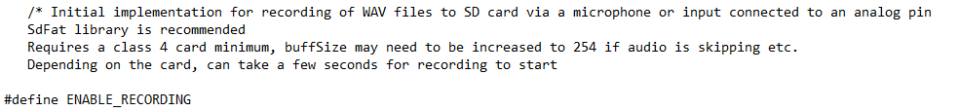

## Step 5: Open the Preferences

Click on the File menu, and select Preferences. Alternatively, the menu can be opened with Ctrl+Comma.

## Step 6: Add the Board URL

Copy the following link into the Additional Board Managers URL

<https://raw.githubusercontent.com/Seeed-Studio/Seeed_Platform/master/package_legacy_seeeduino_boards_index.json>

## Step 7: Connect the Open Playback Recorder to the Computer

Unscrew the two halves of the Open Playback Recorder and plug the microcontroller into the computer using a USB cable.

## Step 8: Program the Microcontroller

In the Tools menu, set the board to Seeeduino Nano, and set the port to whatever port shows up when the microcontroller is plugged into the computer. After this, press the arrow button below the Edit menu to compile the code and upload it to the microcontroller.

## Step 10: Close the enclosure

After the microcontroller has been programmed, put both halves of the enclosure together and secure them in place using two M3 screws

|  |
| --- |
|  |